MODULE 1
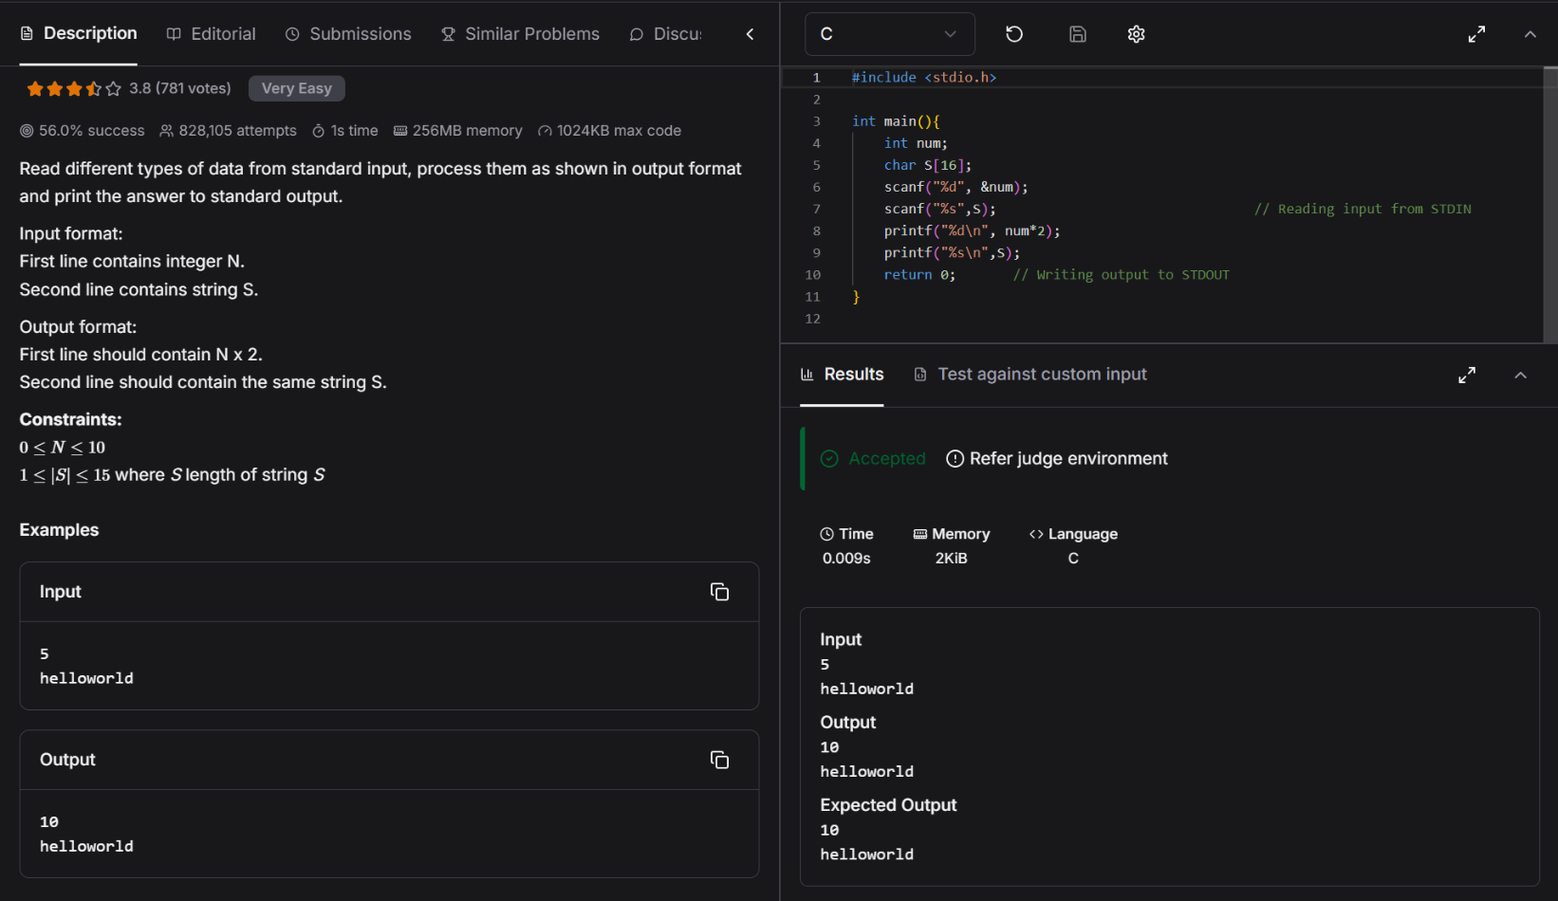
Q1: https://www.hackerearth.com/practice/basic-programming/input-output/basics-of-input-output/practice-problems/algorithm/io-exercise/

